**The Phantom of Spira**

**Developer Handbook**

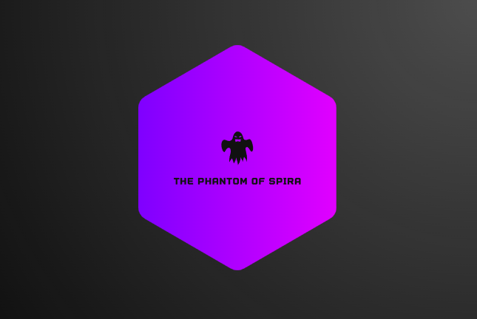

**Please note that this handbook is still under development and any information listed may not be official.**

**Welcome to the Phantom of Spira: A Text-Based MMORPG for open-minded gamers.**

**Table of Contents**

Craftables 2

Determining Resources Needed For Item/Equipment Crafting 2

Determining Item Crafting Levels 2

Determining Resources Needed For Potion Crafting 2

Spells and NatPowers 3

# Craftables

## Determining Resources Needed For Item/Equipment Crafting

* Damage of an element type or the total damage of the item ➗ 100 = The amount of a specific resource.
* If the item has a damage multiple ability, the resources needed will be the multiple times 100 alongside the resources needed from the damage.

## Determining Item Crafting Levels

* The total amount of crafting materials ➗ 10.

## Determining Resources Needed For Potion Crafting

For potions with no static amount of stat bonuses you will need 1 herb needed for the potion and a d100 per resource.

# Spells and NatPowers

Spells with continual effects can only last up to 3 rounds.

The spell costs for spells that do damage are as follows:

* Single target instantaneous damage, damage= X*100 where X is equal to SP or HP spent
* Single target per round damage, damage=X*50 where X is equal to either SP or HP spent
* Multi-target instantaneous damage, damage=X*100 where X is equal to either SP or HP spent
* Multi-target per round damage, damage=X*100 where X is equal to either SP or HP spent

Spell ability costs can be decided however.

# Creating Items

Max hp and sp bonuses on equipment for each world.

* Spira: 5000
* DragonScale: 10000
* Abstara:15000
* Solreach: 20000
* Post Solreach: 25000

Max ACC and ATK bonuses on equipment for each world

* Spira: 10000
* DragonScale: 20000
* Abstara: 30000
* Solreach: 40000
* Post Solreach: 50000